Theoretical neuroscience: Exercise 3  
Date: 14/11/19

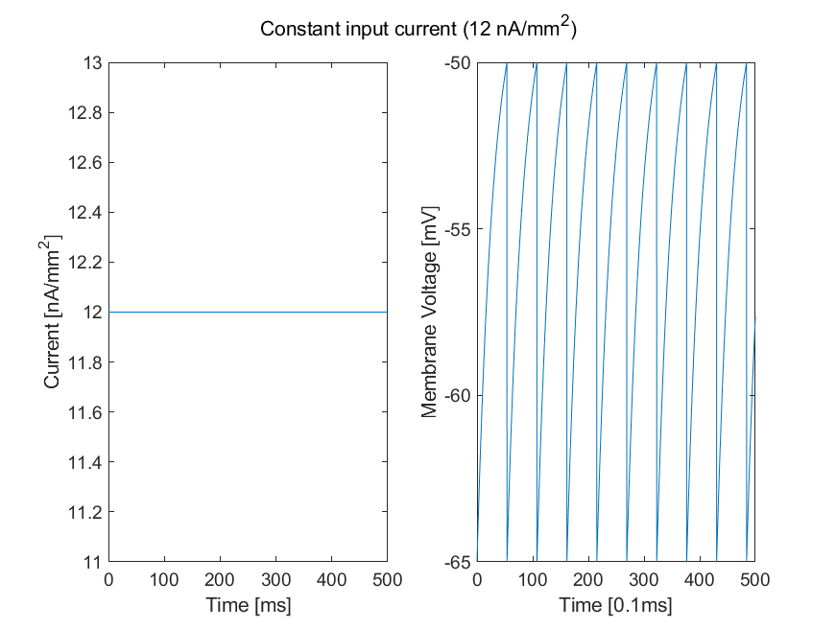

Figure 1: Given a constant input current, we can observe the membrane voltage constantly reaching threshold and spiking. There is, however, no change in inter-spike time.

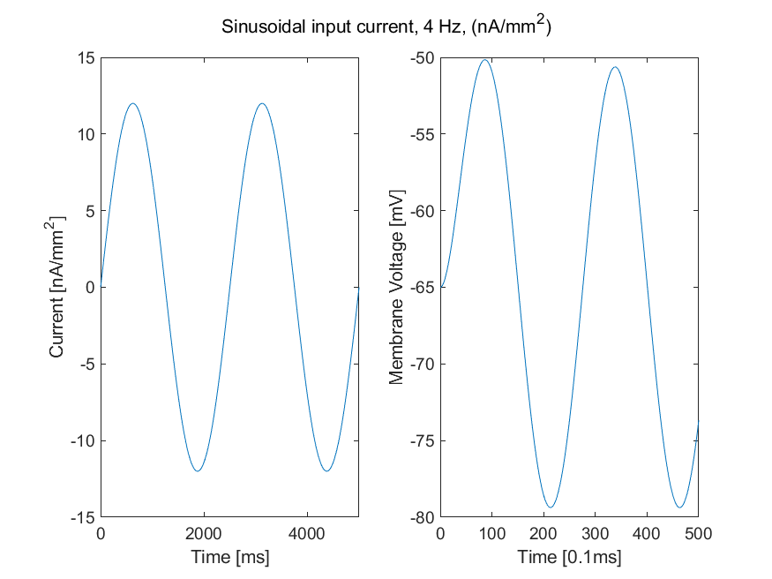

Figure 2: The low frequency sinusoidal input current does not allow the membrane voltage to reach threshold and therefore, no spiking is observed.

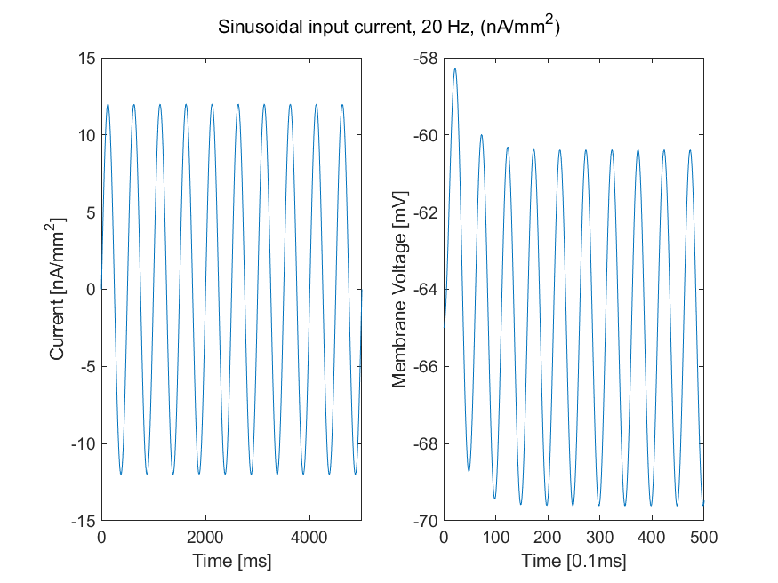

Figure 3: The medium frequency sinusoidal input current does not allow the membrane voltage to reach the threshold and therefore, no spiking is observed.

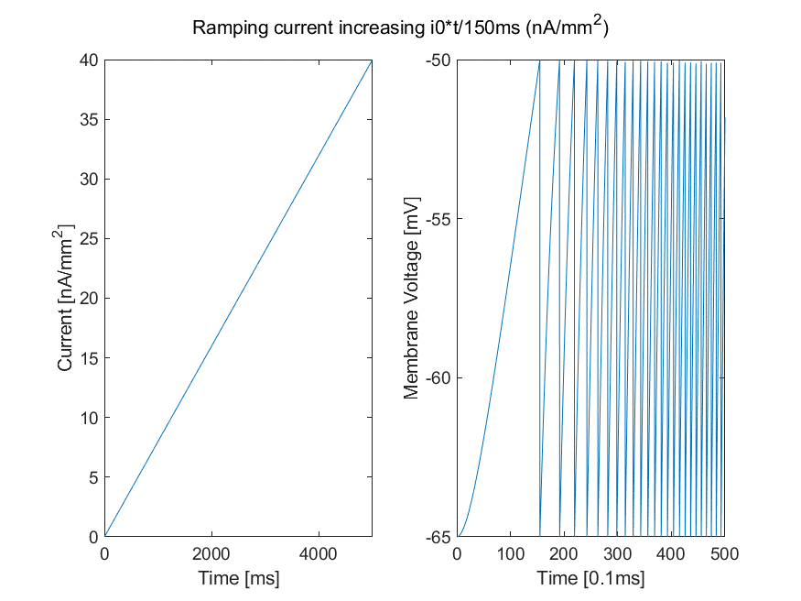Figure 4: The ramping current has a constantly increasing input and therefore after the membrane reaches threshold, the current continues to increase; consequently, it reaches threshold quicker and quicker. Thus, the inter-spike-intervals are decreasing with time.

**Additional task:**

